**Requirement Gathering and Analysis Phase**

**Data Flow Diagram & User Stories**

|  |  |
| --- | --- |
| Date |  |
| Team ID | SWTID1720026558 |
| Project Name | BOOK A DOCTOR USING MERN |
| Maximum Marks |  |

**Data Flow Diagrams:**

A Data Flow Diagram (DFD) is a traditional visual representation of the information flows within a system. A neat and clear DFD can depict the right amount of the system requirement graphically. It shows how data enters and leaves the system, what changes the information, and where data is stored.

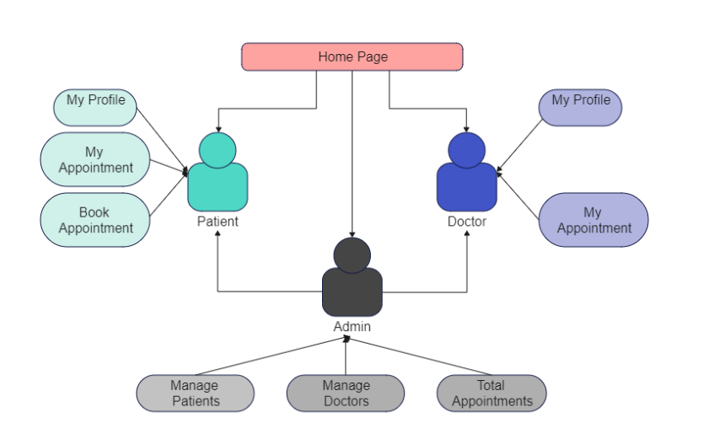

**User Stories**

|  |  |  |  |  |  |  |
| --- | --- | --- | --- | --- | --- | --- |
| **User Type** | **Functional Requirement (Epic)** | **User Story Number** | **User Story / Task** | **Acceptance Criteria** | **Priority** | **Release** |
| Customer (Mobile User) | Registration | USN-1 | As a user, I can register for the application by entering my email, password, and confirming my password. | User can successfully register with valid email and password. | High | Sprint-1 |
|  | Registration | USN-2 | As a user, I will receive a confirmation email once I have registered for the application. | User receives an email with a confirmation link. | High | Sprint-1 |
|  | Registration | USN-3 | As a user, I can register for the application through Facebook. | User can register and access the dashboard via Facebook Login. | Low | Sprint-2 |
|  | Registration | USN-4 | As a user, I can register for the application through Gmail. | User can register and access the dashboard via Gmail Login. | Medium | Sprint-1 |
|  | Login | USN-5 | As a user, I can log into the application by entering email & password. | User can log in with correct email and password. | High | Sprint-1 |
|  | Dashboard |  | As a user, I can view and manage my appointments. | User can see upcoming appointments and manage them. | High | Sprint-1 |
| Customer (Web User) | Registration |  | As a user, I can register for the application using a web interface. | User can register with email, password, and confirmation. | High | Sprint-1 |
|  | Login |  | As a user, I can log into the application using a web interface. | User can log in with email and password. | High | Sprint-1 |
|  | Dashboard |  | As a user, I can view and manage my appointments using the web interface. | User can see and manage appointments. | High | Sprint-1 |
| Customer Care Executive | Appointment Management |  | As a customer care executive, I can view and manage customer appointments. | Executive can view, update, and cancel appointments. | High | Sprint-2 |
|  | Customer Interaction |  | As a customer care executive, I can communicate with customers regarding their appointments. | Executive can send notifications and messages to customers. | Medium | Sprint-2 |
| Administrator | Doctor Approval |  | As an administrator, I can approve new doctor registrations. | Administrator can review and approve or reject new registrations. | High | Sprint-1 |
|  | Platform Governance |  | As an administrator, I can manage user roles, permissions, and overall platform operations. | Administrator can set user roles, manage settings, and ensure compliance. | High | Sprint-1 |